Japan Society - Access to Experts
Request to be listed

Please include as much detail as possible when filling in this form. Below is an example of how your listing will appear. For more information, visit our website: www.japansociety.org.uk/accessexperts

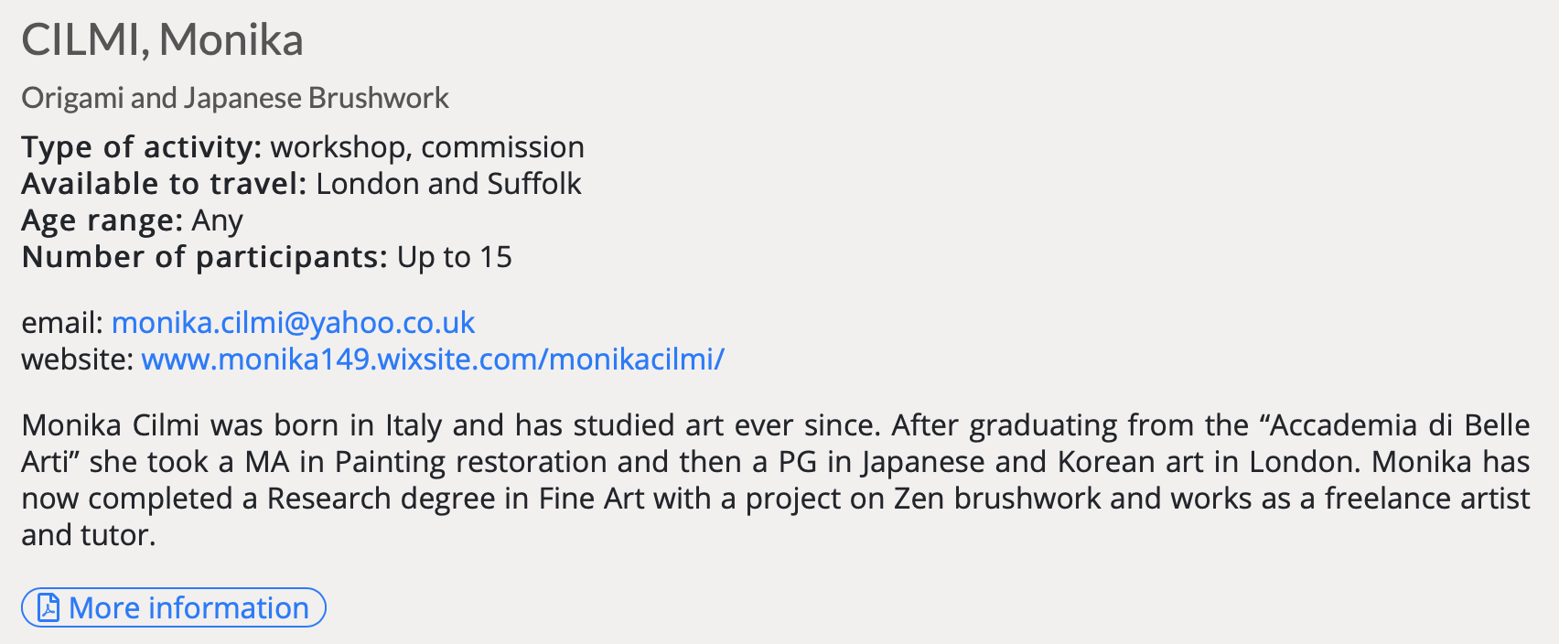

- Contact Details

First name: | Surname:
Email (recommended):
Tel (optional):
Website (recommended):

2 Area of Expertise/Activities

Area of Expertise: e.g Origami, Music, Ikebana

Type of Activity: e.g workshop, lecture, demonstration

Available to travel: (where are you based/how far are you willing to travel?)

Age range:

Number of participants:

3 Bio

optional - please provide a short bio (up to 100 words)

If you would like to include a longer bio, further details and/or images with your listing, please send a separate document which will be included as a downloadable file at the bottom of your listing.

Note: To avoid being blocked by our server, large files should be sent via WeTransfer.

4 Additional Information

Where did you hear about Japan Society Access to Experts?

Japan Society Website Mailing List Search Engine

Other (please specify) ……………………………………………….

Would you like to be added to our mailing list? Yes No

Are you a member of the Japan Society? Yes No*
*are you interested in hearing more about becoming a member? Yes No

Please Confirm
The information provided in this application will be reviewed and you will be notified of the outcome within 10 working days of receipt. If the Japan Society is happy to include your details on Access to Experts, your listing will be added soon thereafter. If there are any changes in your details or you would like to be removed from the list, we request that you contact us as soon as possible. Please note that inclusion on Access to Experts does not imply endorsement by the Japan Society, and listings are for informational purposes only.

I confirm that I have read and understood the above, and that the information contained in this application is correct and I am happy for my contact details to be available publicly on the Japan Society Website.

Signed: Date:
Submission of this form by email implies confirmation of the statement above.

Please return this form by email to: info@japansociety.org.uk

