Published by:
Renaissance Books, PO Box 219, Folkestone, Kent CT20 2WP, UK
Tel: +44 (0)1303 226799
Email: info@renaissancebooks.co.uk; Website: www.renaissancebooks.co.uk

Available from:

UK Distributor
Orca Book Services, 160 Eastern Avenue, Abingdon, Oxon OX14 4SB, UK
Direct customers (non-account holders) –
Tel: +44 (0)1235-465500; Email: direct.orders@marston.co.uk
Trade customers (account holders) –
Tel: +44 (0)1235 465521; Email: trade.enquiry@marston.co.uk

Qty | Title | Author | ISBN | Price | Total Price
 | The Call of Japan | Hans Brinckmann | 978-1-912961-14-6 | £24.95 22.50
 | Postage & Packing: UK – Free Europe £9.50; ROW £12.50 |  |  | P& P | Free [UK only]
 |  |  | Grand Total

_____________________________________________________________________________________

Method of payment
Please send me ___ copy/ies of The Call of Japan at the special promotional price of £22.50 [incl. UK postage] per copy
I enclose a cheque made payable to Orca Book Services for £_________
Please send me a pre-payment invoice. My Ref. No. _________
Please charge my credit card: MasterCard □ VISA □
Please put me on the Renaissance Books mailing list: □

Card Number

Security Number (Three digits) _______

Expiry date _________ Signature _________________________________________________________
NAME _______________________________________________________________________________
INSTITUTION _________________________________________________________________________
ADDRESS ___________________________________________________________________________
____________________________________________________________________________________
TELEPHONE NO. ________________________________ FAX NO. _____________________________

RETURN COMPLETED ORDER TO:
Orca Book Services, at the address given above.
ORDER CODE: 13JAPAN

NOTE: This promotional price is only available through Orca Book Services.

Hans Brinckmann
The Call of Japan
A Continuing Story – 1950 to the Present Day

ISBN 978-1-912961-14-6 Published June 2020

Pages 312 + xix + 16pp col. plates

SPECIAL PROMOTIONAL PRICE 24.95 £22.50 [incl. postage]

‘This is the story of a young Dutchman who, after having withstood the vicissitudes of WW2 in his home country, embarked on a life in a foreign country on the other side of the globe. At eighteen he finds himself living in a nation suffering from the aftermath of a vicious war. Remarkably, he does not flee from it but immerses himself in it. He recounts how he comes to grips with the intricacies of the customs, culture and mentality of Japan, setting him apart from other foreigners who escape into a simulation of their home countries’ way of life.  In the course of his long residence in Japan, he became acquainted with people of all walks of life including the emperor-to-be. By means of anecdotes and observations he tells us the background of the country’s sometimes-strange customs and habits. He even ventured into Zen-Buddhism and other religious movements.  Brinckmann has now reached an age to look back upon life. Hardly any 'foreigner' can boast of seventy years’ experience in Japan as he did after having lived there for more than forty years. ‘  (From a review by Y.C. Rogge, Amsterdam) | 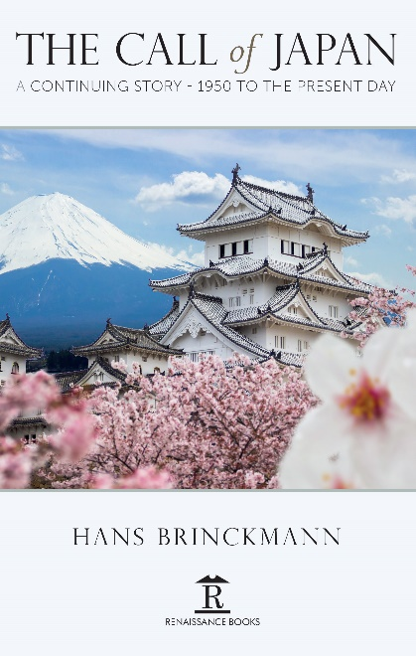

Published by: Renaissance Books, PO Box 219, Folkestone, Kent CT20 2WP, UK
Tel: +44 (0)1303 226799
Email: info@renaissancebooks.co.uk; Website: www.renaissancebooks.co.uk
Available from: UK Distributor
Orca Book Services, 160 Eastern Avenue, Abingdon, Oxon OX14 4SB, UK
See reverse for telephone and email contacts.

